DATA ANALYTICS AND VISUALIZATION
4. Text Analytics
4.1 History of text mining, Roots of text mining overview of seven practices of text analytic, Application and use cases for Text mining: extracting meaning from unstructured text, Summarizing Text.
Text Analysis Steps, A Text Analysis Example, Collecting Raw Text, Representing Text, Term Frequency—Inverse Document Frequency (TFIDF), Categorizing Documents by Topics, Determining Sentiments, Gaining Insights.
PAST QUESTIONS:
- List and explain methods that can be used for sentiment analysis. (M23)
- List and explain the steps in the Text Analysis. (M23)
- Explain with suitable example how the Term Frequency and Inverse Document Frequency are used in information retrieval. (M23)
- Explain term frequency (TF), document frequency (DF), and inverse document frequency (IDF). (D23)
- What is text mining? Enlist and explain the seven practice areas of text analytics. (D23)
- Explain Term Frequency-Inverse Document Frequency (TF-IDF) with a suitable example. (M24)
- Explain in detail seven practice areas of text analytics. (M24, D24)
- Enlist and explain the steps of text analysis. (M24, D24)
- What is a text summarizer? How does it work? Explain the difference between extractive summarization and abstractive summarization. (D24)
NOTES:

*Text Mining :-
Text mining, also known as text data mining or text analytics, is the process of extracting useful information and patterns from unstructured text data using techniques from natural language processing (NLP), machine learning, and statistics.
It involves converting text into data that can be analyzed using a variety of computational methods.
Role in Data Analytics:
1. Extracts Insights from Unstructured Data -
Over 80% of data in organizations is unstructured—emails, customer reviews, documents, social media posts, etc. Text mining helps analyze and organize this raw text into useful information.
2. Supports Better Decision-Making -
By analyzing customer feedback, surveys, or support tickets, businesses can make data-driven decisions to improve services, products, and customer satisfaction.
3. Enables Sentiment and Trend Analysis -
Text mining helps identify public opinion, emerging issues, or trending topics from online content like reviews, tweets, and forums.
4. Automates and Enhances Processes -
It powers spam filters, chatbots, document categorization, and email sorting, saving time and reducing human effort.

Real World Application:
Healthcare:
Text mining automates the extraction of valuable information from vast medical literature, saving time and improving research efficiency in the biomedical field.
CustomeraService:
Text mining and sentiment analysis help businesses analyze feedback from chatbots, surveys, NPS, online reviews, and social media to identify customer pain points and respond to issues in real time, improving customer satisfaction.
Spam filtering:
Spam frequently serves as an entry point for hackers to infect computer systems with malware. Text mining can provide a method to filter and exclude these e-mails from inboxes, improving the overall user experience and minimizing the risk of cyber-attacks to end users.

*Steps in Text Analysis :-
Parsing is the process that takes unstructured text and imposes a structure for further analysis. The unstructured text could be a plain text file, an Extensible Markup Language (XML) file, a HyperText Markup Language (HTML) file, or a Word document. Parsing deconstructs the provided text and renders it in a more structured way for the subsequent steps.

Search and retrieval is the identification of the documents in a corpus that contain search items such as specific words, phrases, topics, or entities like people or organizations. These search items are generally called key terms.

Text mining uses the terms and indexes produced by the prior two steps to discover meaningful insights pertaining to domains or problems of interest.

Part-of-speech The goal of POS tagging is to build a model whose input is a sentence, such as:
Example:
Input: he saw a fox
Output: PRP VBD DT NN
the four words are mapped to pronoun (personal), verb (past tense), determiner and noun (singular), respectively.

Lemmatization Reduces words to their dictionary base form (lemma) using a dictionary and rules.
Example:
Input: obesity causes many problems
Output: obesity cause many problem

Stemming A rule-based process of removing word affixes to obtain the word stem.
Example:
Input: obesity causes many problems
Output: obes caus mani problem
*Seven practices of Text Analytics :-
Text mining can be divided into seven practice areas, based on the unique characteristics of each area.
1. Search and information retrieval (IR): It is the process of obtaining relevant documents or text data from a large collection based on a user’s query. The goal is to retrieve only the most relevant information instead of the entire dataset.
2.Document clustering: Document clustering uses algorithms from data mining to group similar documents into clusters. It is an unsupervised learning technique used to group similar documents together based on content similarity
3. Document classification: Document classification assigns a known set of labels to untagged documents using models trained on labelled examples.
4. Web mining: Web Mining is the practice of using text analytics, data mining, and machine learning techniques to extract useful information from data available on the World Wide Web. It helps in discovering patterns, user behaviour, and knowledge from web-based content.
5. Information extraction (IE): Identification and extraction of relevant facts and relationships from unstructured text; the process of making structured data from unstructured and semi structured text.
6. Natural language processing (NLP): Natural Language Processing (NLP) is a branch of AI that enables machines to understand, interpret, and generate human language.
Common NLP tasks: Tokenization, Part-of-Speech (POS) tagging, Lemmatization and stemming, Syntax parsing
7. Concept extraction: to identify semantically meaningful concepts, even if they are expressed using different words.

*Sentiment Analysis :-
Sentiment analysis is the process of analyzing digital text to determine if the emotional tone of the message is positive, negative, or neutral. Today, companies have large volumes of text data like emails, social media comments and reviews. Sentiment analysis tools can scan these texts to automatically determine the author’s attitude towards a topic. Companies use the insights from sentiment analysis to improve customer service and increase brand reputation.
In text mining, sentiment analysis is a key tool to derive emotional or subjective meaning from large volumes of textual data.
Social Media Monitoring | Analyzing tweets or posts to gauge public opinion on events, brands, or policies.
Customer Feedback | Understanding customer satisfaction from reviews, surveys, or support tickets.
Brand Management | Tracking how people feel about a product or company over time.
Market Research | Identifying consumer trends and product preferences.
Political Analysis | Evaluating public sentiment on candidates or issues.

*TF-IDF :-
TF-IDF (Term Frequency-Inverse Document Frequency) is a powerful technique used to analyze and understand the importance of words in a document corpus. TF-IDF plays a crucial role in tasks such as text mining, information retrieval, and document classification.
TF-IDF is a numerical statistic used to evaluate how important a word is to a document in a collection or corpus.
The idea behind TF-IDF is to quantify the importance of a term in a document with respect to its frequency in the document and its rarity across multiple documents.
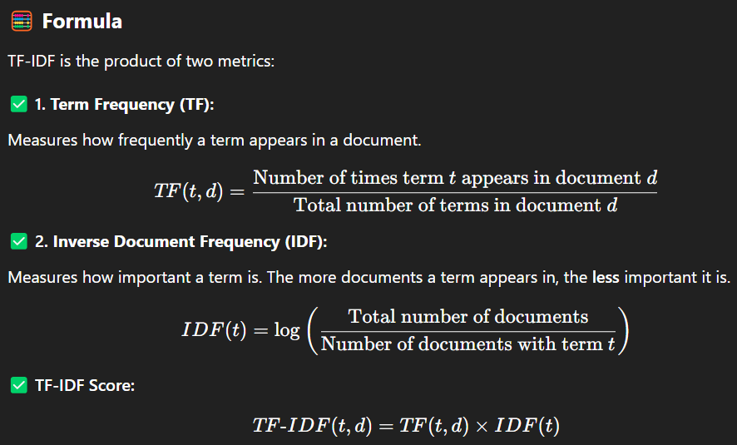
Example:
